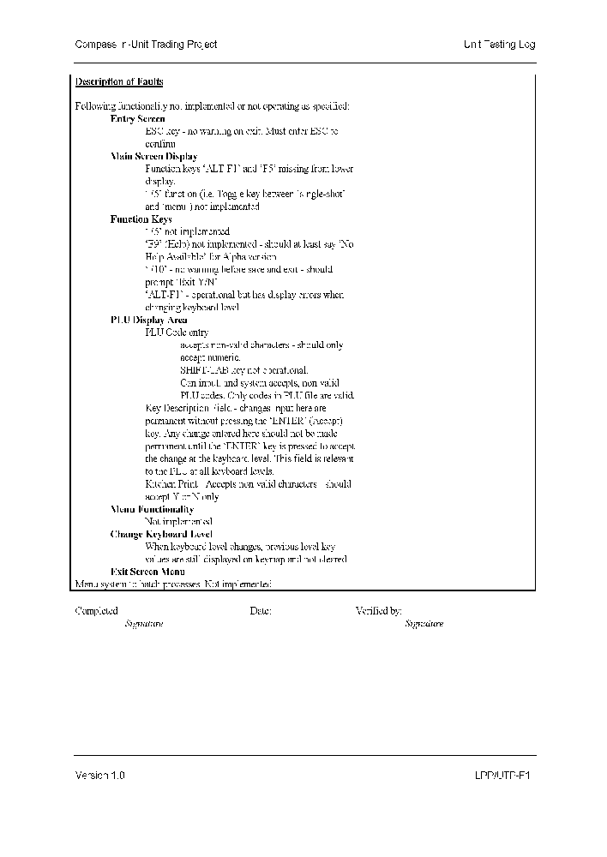

Fixed Note ¬Fixed Note ­FixedFixedFixed Note ®FixedFixed Note ¯FixedFixedFixedFixedFixedFixed

